Risk Profiler

Select Boundary: Municipal View Data By: Threat: New? Take The Tour

Risk Layer

Adjust Opacity

Legend

Intensity Layer

Adjust Opacity

Legend

**+**

**-**

Data By:

Area Scenario Training Download About Contact

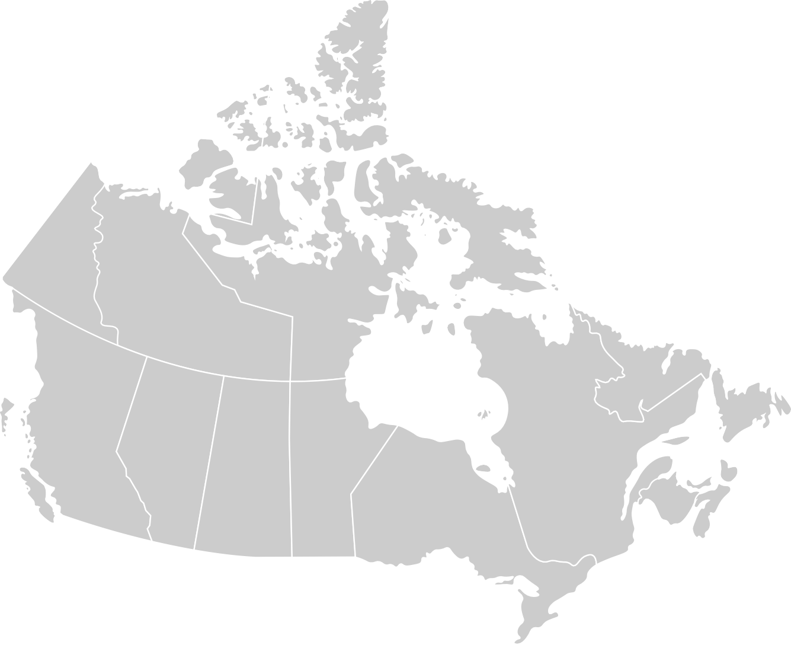

Sentence about what scenarios are and how they can help

To begin, select a municipality:

or

Search Municipality

Go

Video loop showing how UI works

View All Scenarios

Footer